Dear Students and Parents,

**Math Module 2 (Grade 4)**

**Unit Conversions and Problem Solving with Metric Measurement**

Here is a list of key vocabulary words and skills that will be explored during this math module. Take the time to read and think about the words and skills. HIGHLIGHT the words you already know and put a QUESTION MARK next to the words you are unfamiliar with or unsure of what they mean.

***Vocabulary:*** *(What words will I learn…)*

|  |  |  |  |
| --- | --- | --- | --- |
| kilometer | mass | millimeter | mixed units |
| capacity | convert | distance | number line |
| equivalent | estimate | reasonableness | kilogram |
| larger unit | smaller unit | length | liter |
| measurement | dimensions | quantity | approximation |
| comparison | liquid volume | meter | centimeter |
| beaker | ruler | meter stick | measuring tape |
| scale | weights | mass | kilogram |
| tape diagram | algorithm | express | simplifying strategy |
| gram | statement |  |  |

***Practice:***  *(How can I continue to grow…)*

We all learn differently and master concepts at various times. Here are a few web links for anytime practice whether you need to review a skill, try the skill at a harder level, or challenge yourself to the next grade level’s use of these math concepts. And…***Please remember to frequently practice math facts for automaticity as this will help you with more advanced math concepts.***

[](http://school.discoveryeducation.com/clipart/clip/calcultr.html)<http://tenmarks.com> and <http://sumdog.com> (Your child has a school account)

<http://www.arcademicskillbuilders.com>

<http://www.funbrain.com/tictactoe/index.html>

<http://www.aplusmath.com>

**Parent Signature: ________________________________**

***Learning Targets:*** *(What concepts will I master…)*

Three times each math module, you will reflect on how proficient you are with each of the concepts we will be studying*.* The goal is to make progress towards consistently meeting the learning target by the end of fourth grade!

***C:\Users\burkea\AppData\Local\Microsoft\Windows\Temporary Internet Files\Content.IE5\XP69NYCW\MC900352510[1].wmfProgress Self-Assessment:***

**4- Bull’s-eye! I can do this well all the time.**

**3- Close! I know what I’m doing, just need more practice**

**2- Getting better. I’m starting to understand what to do.**

**1- Just beginning. I’m not sure how to do this yet.**

|  |  |  |  |
| --- | --- | --- | --- |
| **Learning Targets for Math Module 1** | **Beginning** | **Middle** | **End** |
| I can show that I know the **relative size of measurement units** within a single system. 4.MD.1  *For example, know that 1 ft is 12 times as long as 1 in. Express the length of a 4 ft snake as 48 in. Generate a conversion table for feet and inches listing the number pairs (1, 12), (2, 24), (3, 36), …* |  |  |  |
| I can **show** the **measurements** of a larger unit in terms of smaller units and **record** these in a table. 4.MD.1 |  |  |  |
| I can **solve addition** and **subtraction word problems** involving **metric length**. 4.MD.2 |  |  |  |
| I can **solve addition** and **subtraction word problems** involving **metric mass**. 4.MD.2 |  |  |  |
| I can **solve addition** and **subtraction word problems** involving **metric capacity**. 4.MD.2 |  |  |  |
| I can **represent measurement quantities** using diagrams such as number line diagrams that feature a measurement scale. 4.MD.2 |  |  |  |
|  | | | |
| **Review Targets for Math Module 2** |  |  |  |
| I can **fluently add and subtract large numbers**.  4.NBT.4 |  |  |  |
| I can use what I know about addition, subtraction, multiplication and division to **solve multi-step word problems** involving whole numbers. 4.OA.3 |  |  |  |
| I can **represent word problems** by using equations with a **letter** standing for the **unknown** number. 4.OA.3 |  |  |  |

Additionally, all students will be continuing work on these mathematical practice standards: “I can make sense of problems and persevere in solving them.” MP1; “I can look for and use structure to make my work easier.” MP7; “I can look for patterns in my work.” MP8.

Visual Models

Number Bonds – taking apart the whole and finding pieces that make up the whole

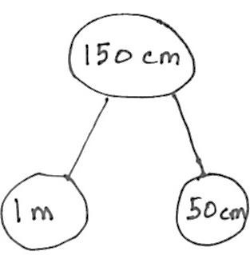

Sample problem using a tape diagram

Martha, George, and Elizabeth sprinted a combined distance of 10,000 meters. Martha sprinted 3,206 meters. George sprinted 2,094 meters. How far did Elizabeth sprint? Solve using a simplifying strategy or an algorithm.

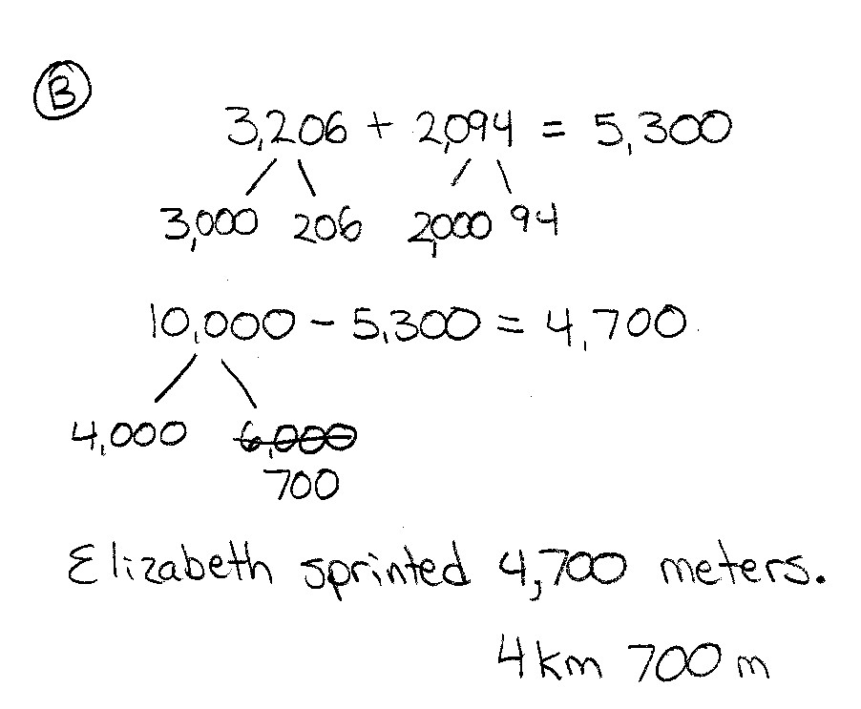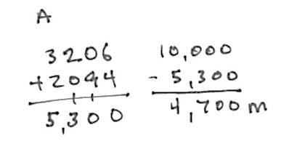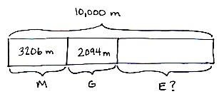

Solving problems using number lines

